BIS638: Using SQL for Business Intelligence
R. George Hauser, MD

Overview
You oversee a hospital with inpatient and outpatient services. Patients who visit your hospital receive laboratory tests as part of their care. A particular test, flow cytometry, is performed by both an in-network laboratory and an out of network laboratory. Clinicians who order this test have a choice between either laboratory. Some clinicians prefer the in-network laboratory, while others prefer the out of network laboratory. The practice of where to send the flow cytometry is not standardized, creating confusion among healthcare providers. They would like your help to review of historical ordering patterns as a guide to their development of rationale ordering criteria.
The enclosed file contains all the data you need. It was extracted from the hospital’s data warehouse for this analysis. It is deidentified of personal health information to comply with HIPAA. Load it into your Azure SQL database. Use the file name as the table name (i.e., FlowCytometry). Answer the questions below with a single SQL file named “BIS638-homework2.sql”. Followed the template below exactly to assist with scoring the homework. All answers consist of a single SQL statement; do not create new tables.
BIS638-homework2.sql
--1.
select distinct TestName from HelloWorld.FlowCytometry20220914_DeId order by TestName
-----
--2.
-->repeat the pattern above with sequential numbers and code
-----

1. Tests Performed
Different versions of the flow cytometry test are available. What versions of flow cytometry are present in the dataset? Order the output by TestName alphabetically.
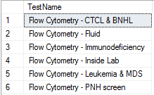

2. Test Counts
How many of each version of the flow cytometry test were performed? Order them so the most common test is the first row.
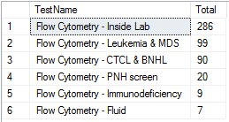

3. Find Examples
Patient names are needed for each version of the flow cytometry test. Clinical staff would like to review the cases to learn more about why the tests were ordered. Select the most recently completed tests for each test version.
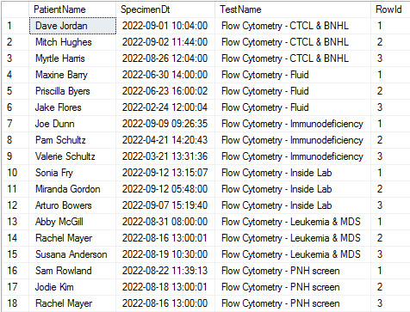

4. Turnaround Time
Clinicians have learned the out of network laboratory is thought to have a short turnaround time (e.g., time from specimen collection to test completion). Review the data for both labs to determine who has the shorter turnaround time measured by arithmetic mean and median. Format the times in days as shown below (1440 minutes/day).
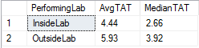

5. Day of Week – In Network
The in-network lab does not perform flow cytometry on Friday. All specimens collected on Friday should go to the out of network lab. Review the data to see if exceptions to this practice have occurred.
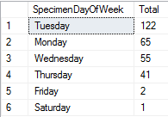

6. Day of Week – Out of Network
The out of network lab should receive few specimens Monday to Thursday while the in network lab operates. Add the out of network lab to the day of the week query above, ordering by day of week then performing lab.
